I have used CO₂ lasers during my training and fellowship, so I have wanted to bring this technology into my own practice for some time.

Now that I have my own system, I can offer fractional CO₂ resurfacing for concerns such as uneven skin texture, fine lines, changes around the mouth and selected areas of wrinkling around the eyes.

It may also be useful for some patients considering eyelid surgery who have skin-quality concerns but do not necessarily have significant excess skin or puffiness.

The platform also has a surgical setting, which can be used in selected cases for the removal of certain skin tags and other small lesions following appropriate assessment.

What excites me is the range of options it adds. It allows me to consider skin quality alongside facial surgery and recommend treatment according to what each patient actually needs.

As with any laser procedure, suitability, expected recovery and potential risks need to be discussed during a consultation.

One of the questions I hear most about CO₂ laser is: what does it actually feel like?

My lovely client kindly shared her experience straight after treatment. Her full-face session took around 20 minutes, and she described it as a light tickling sensation followed by warmth underneath the skin.

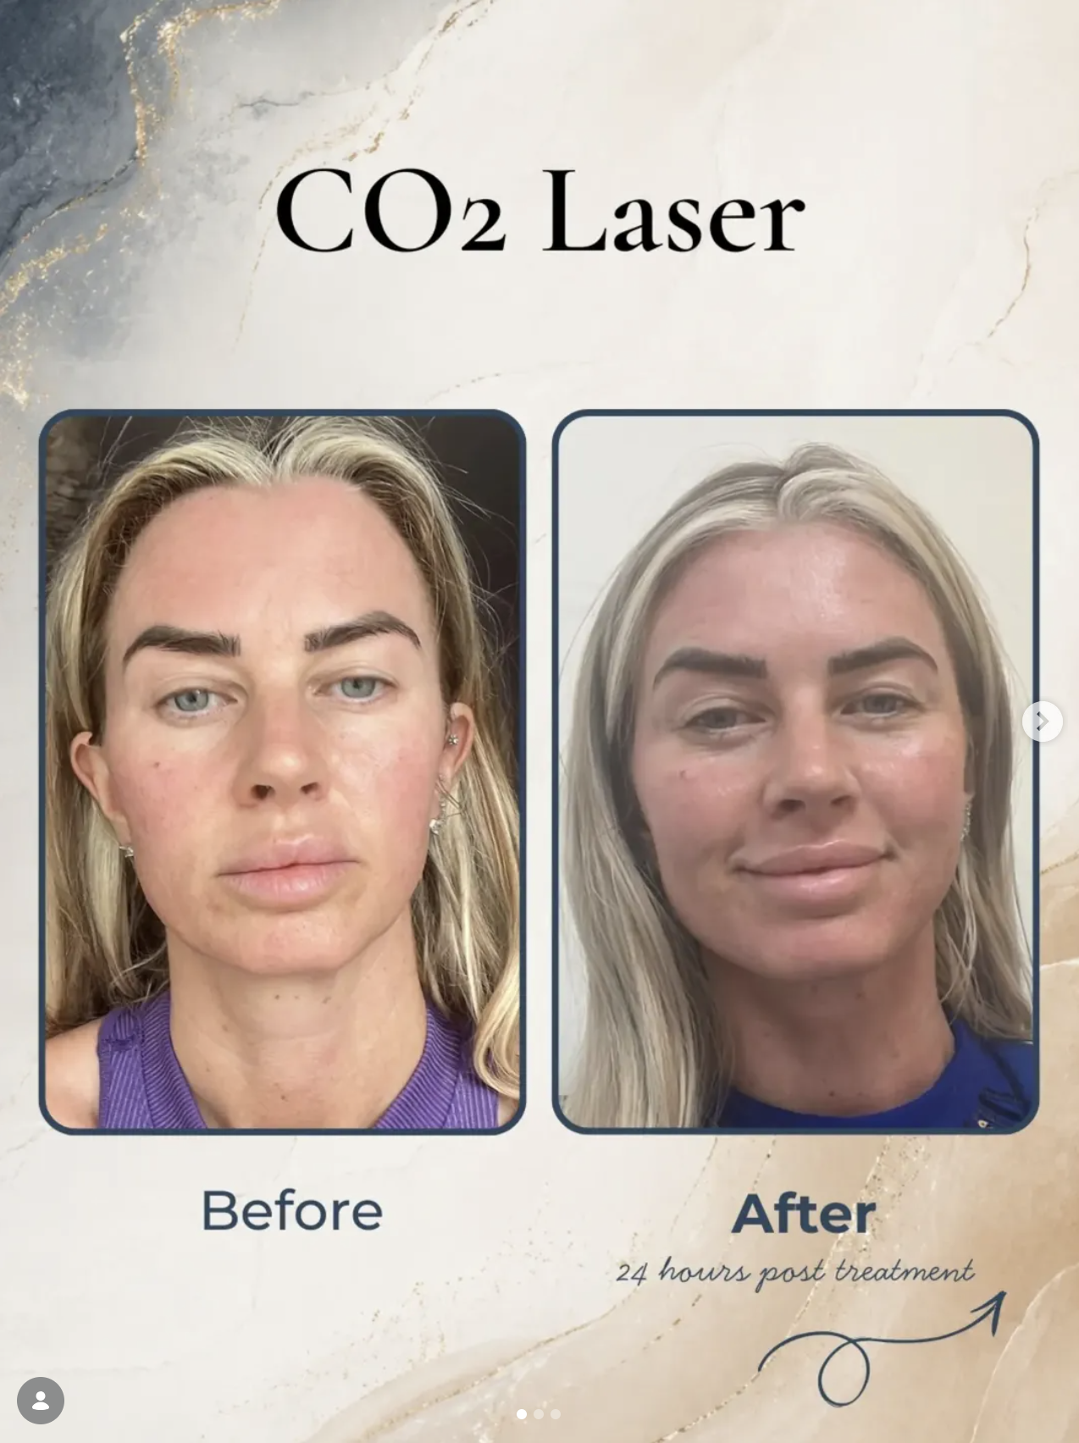

Immediately afterwards, some heat and redness are expected. We then move into aftercare, including the recommended cream and careful SPF protection.

The treatment itself can be relatively quick, but the healing process afterwards is just as important.

CO₂ laser recovery changes quite quickly in the first few days, and every stage can look a little different.

At around 48 hours, redness and the small grid-like treatment marks can still be very visible. The skin may feel dry, tight or rough as the healing process gets underway.

By day five, those superficial areas are often starting to flake away more noticeably, with fresher skin gradually becoming visible underneath.

This is why I always tell patients not to judge the treatment too early. The first few days are very much part of the recovery process, not the final result.

There are still more stages to come as the redness settles, the skin barrier continues to recover and the overall texture gradually improves.

Good moisturising, careful SPF use and following the recommended aftercare remain important throughout.

Mr Gautham Ullas

